**SQL Database**

**Life Expectancy Summaries**

**Task a. Total count of Male, Female per year**

Query Design and Output:

Alternative Query Design and Output:

**Task b. Total count of Male, Female per location**

Query Design and Output:

**Task c. Average of Hale and Life Expectancy per location**

Change the Column Name Location Data Type to NVARCHAR (100) as getting the following error:

*Msg 306, Level 16, State 2, Line 5 The text, ntext, and image data types cannot be compared or sorted, except when using IS NULL or LIKE operator.*

After refreshing the table the Location data type has changed in the HALElifeExpectancyAtBirth Table:

Now I have used the Union function to join both Hale and life Expectancy tables

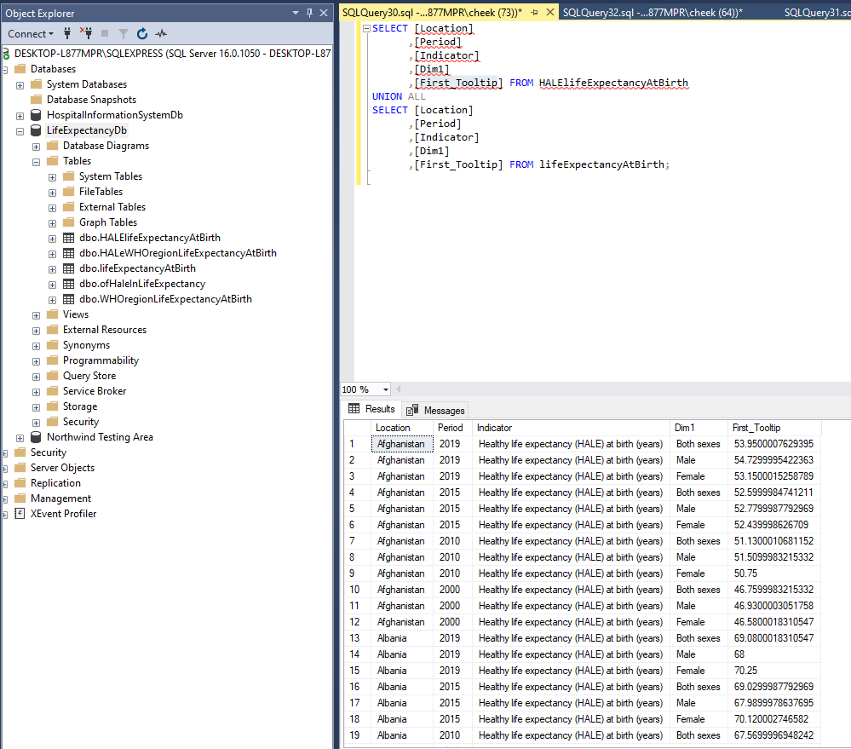

Now I have found the Average of First_Tooltip but lost the Location results- not sure why this has happened?

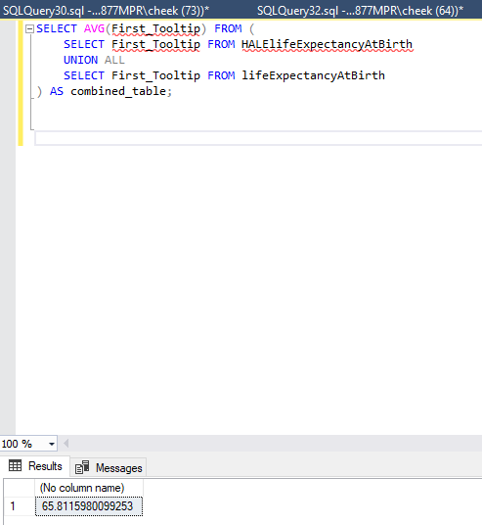

**Task d. Average of Male, Female location of Life Expectancy At Birth per period**

**Task e. Lowest locations of Male, Female of Life Expectancy At Birth less than 50**

**Task f. Highest location of Male, Female of Life Expectancy At Birth greater than 80**

**Task g. Highest % increase location of Male, Female of Life Expectancy At Birth**

**Task h. Total count of Male, Female of HaleWHO region Life Expectancy At Birth per year**

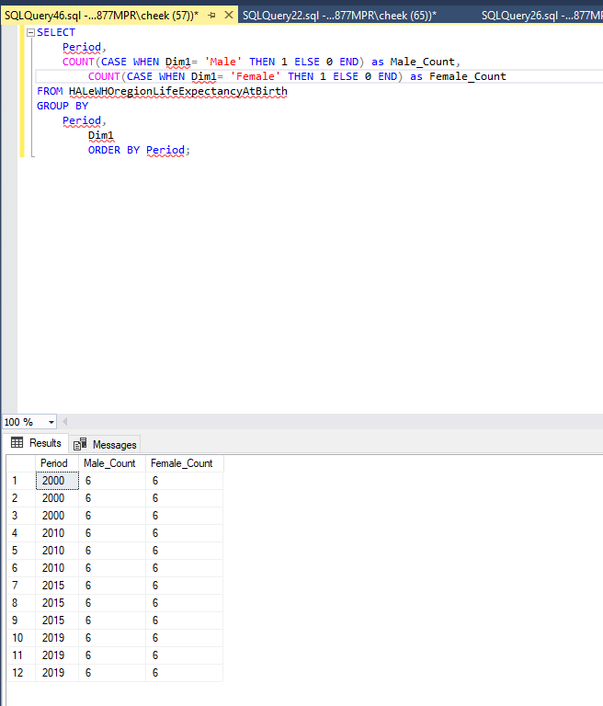

**Task i. Total count of Male, Female of HaleWHO region Life Expectancy At Birth per location**

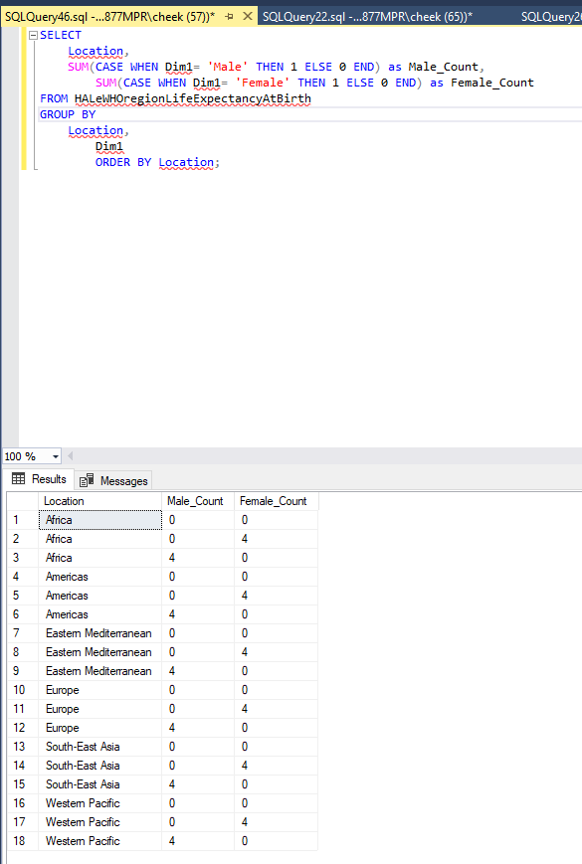

**Task j. Average of Male, Female of HaleWHO region Life Expectancy At Birth per period**

**Task k. Lowest region of Male, Female of HaleWHOLife Expectancy At Birth**

**Task l. Highest region of Male, Female of HaleWHO Life Expectancy At Birth**

**Task m. Highest % increase region of Male, Female of HaleWHO Life Expectancy At Birth**

